Safety Mechanism for Shredder Machine using Computer Vision

⭐️healthy way of using shredder machines⭐️

Demo video link (https://www.kapwing.com/videos/65f6be648bcc606dd3782086)

## Team Details

`Team number` : VH037

| Name | Email |

|CHEBROLU VENKATA TWISHASRI|9921004130@klu.ac.in|

| CHALLA MAHESH BABU | 9921004122@klu.ac.in |

| GONUGUNTLA SHARMILA | 9921004231@klu.ac.in |

| NARA GANESH | 99210041679@klu.ac.in |

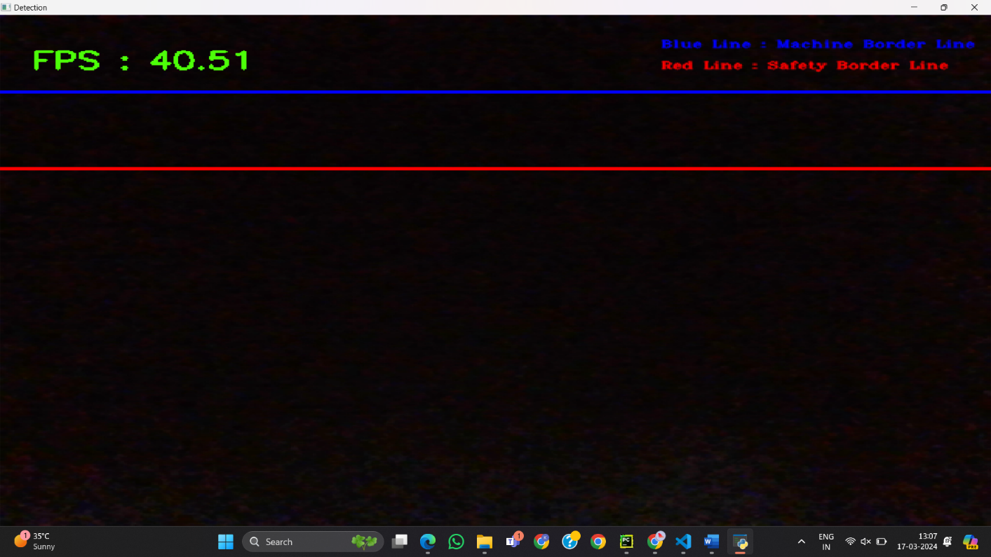

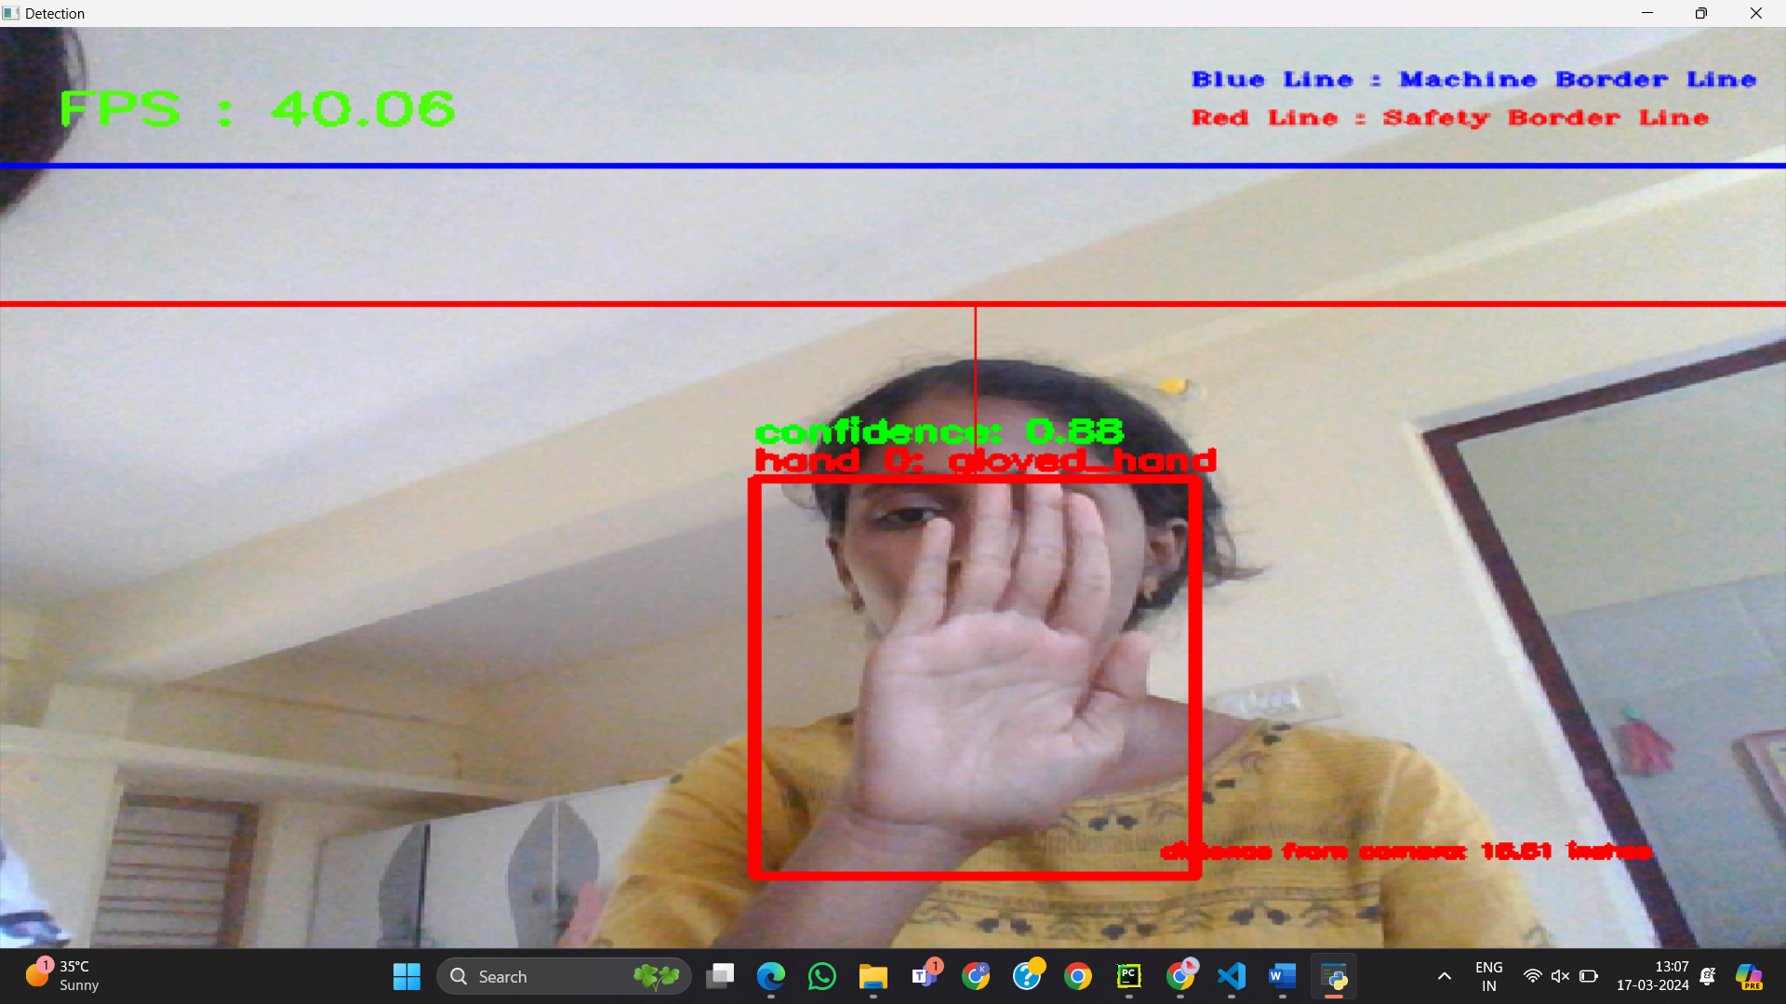

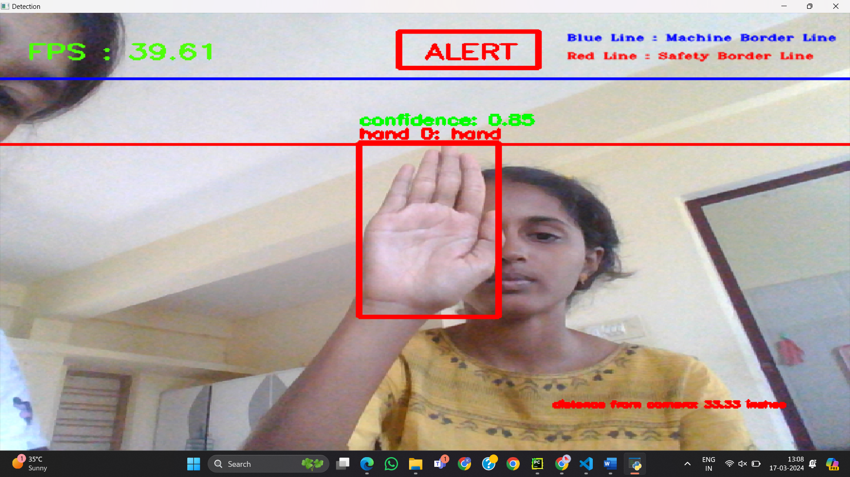

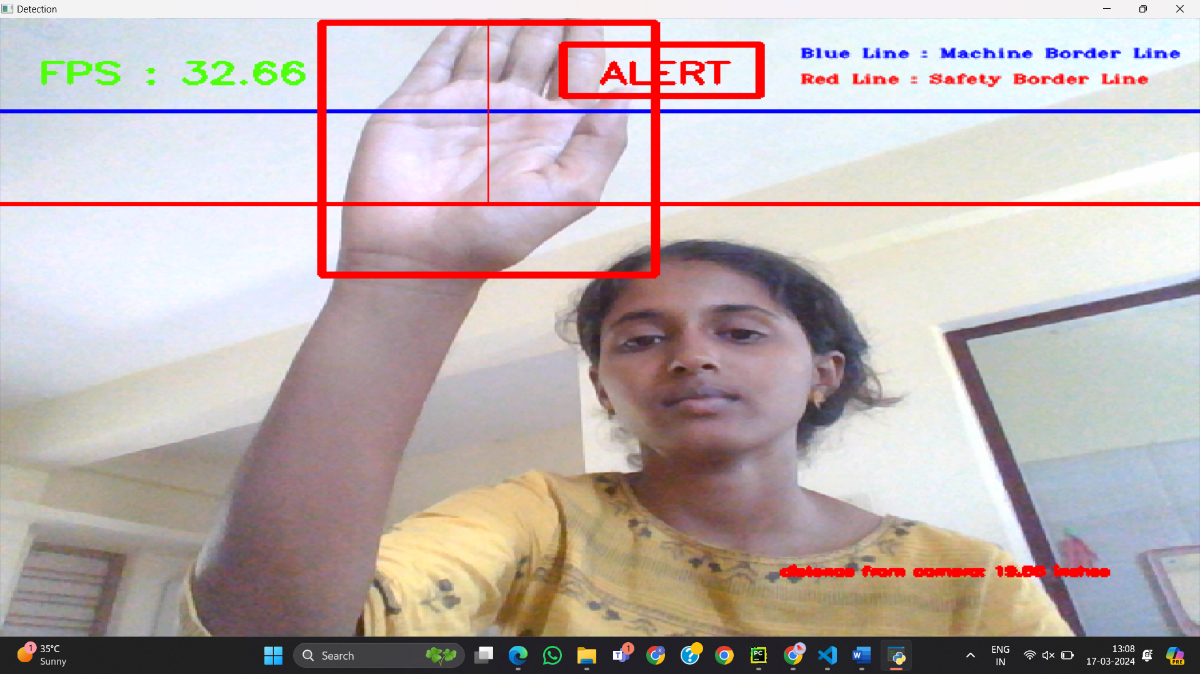

</div>

## Problem statement

The Aim of creating a safety mechanism for a shredder system is to protect individuals, property, and the environment from potential hazards and accidents associated with the operation of the shredder.Shredders are powerful machines that can pose significant risks if not operated safely. By prioritizing safety and implementing appropriate safety mechanisms, you can reduce the risks associated with operating a shredder system, protect personnel and equipment, and ensure compliance with regulatory requirements.

## Technical implemntaion

The proposed safety system can make shredder systems safer for workers, reducing the risk of accidents and injuries

• The system provides a comprehensive approach to worker safety, utilizing a combination of technologies, procedures, and policies to prevent accidents, mitigate risks, and respond to emergencies

• Here proposed model that we have chosen is object detection method.

• The proposed model is designed to improve the shredder system's efficiency and safety by spotting possible dangers, such a worker's hand, before they result in an accident

• These feeds can be processed using the pretrained zoo object detection model to detect and localize objects in the shredder system

• To recognize and locate these hands in real-time video feeds, the model may, for example, be trained on a dataset of photos of worker hands in the shredder system.

• For implementation this work, we are using PyCharm (python IDE). Several libraries like open CV and zoo tensor flow object detection model. The figure below outlines the system's operation.

FLOWCHART:-

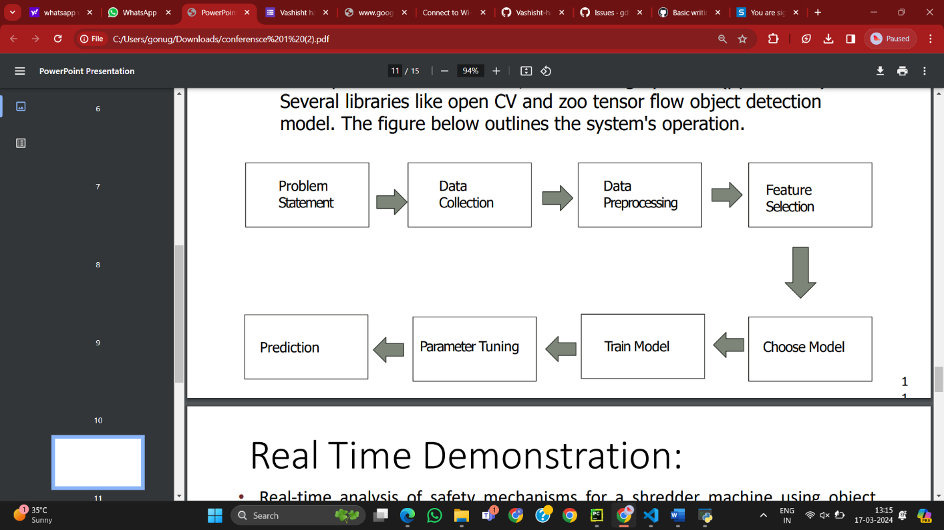

## Techstacks used

Visual Studio , Anaconda , Computer Vision ,Python , Tensorflow ,zoo object detection model.

## How to run locally

• The main file to select is python hand_detection.py all other files required is linked to the file

• Real-time analysis of safety mechanisms for a shredder machine using object detection can be a critical component in ensuring the safety of workers and preventing accidents in industrial settings.

• Object detection involves using computer vision algorithms to identify objects in real-time video streams, and this can be applied to identifypotential hazards in a shredder machine.

In this image it only recognize the hand.it wont recognize. Any another object.. It recognize using the object detection Using dataset

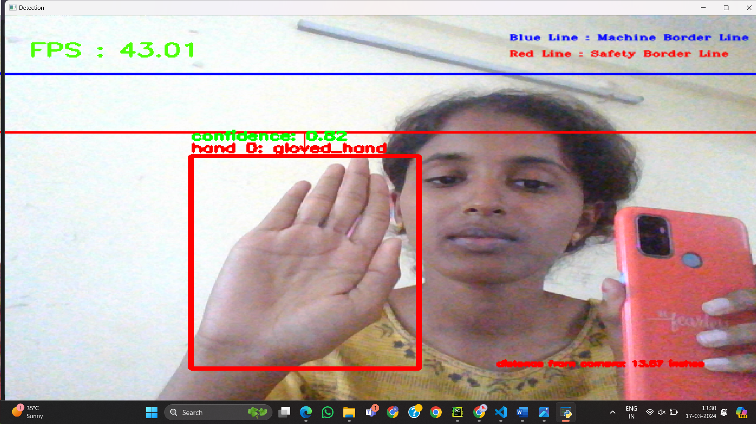

The hand is recognized . It is present below the red line .That means it is in the safe region. So it wont show any alert signal.



The hand is recognized .It is crossed the limit line that means it crosses the red line .It is in danger region so it give’s the alert Signal . it gives the alarm sound.



# What's next ?

We are trying to tieup with shredder machine manufacturers and add our safty to the machine in manufacturing stage.

## Declaration

We confirm that the project showcased here was either developed entirely during the hackathon or underwent significant updates within the hackathon timeframe. We understand that if any plagiarism from online sources is detected, our project will be disqualified, and our participation in the hackathon will be revoked.